The case of the three cultural goods from Mesopotamia

Information sheet on the restitution of three Mesopotamian cultural goods to the Republic of Iraq

24 May 2024

Confiscation during a criminal procedure in the canton of Geneva
The three Mesopotamian cultural goods were confiscated in 2023 during a criminal procedure by the Tribunal de Police in the canton of Geneva. The main accused party in the case was given a custodial sentence for contravening the Cultural Property Transfer Act (transfer of stolen or looted cultural goods) and document forgery. In the same judgement, a further 43 cultural goods were confiscated by the Confederation.
The three cultural goods were discovered and documented during official excavations in Iraq in 1856/57, 1959 and 1976. They were subsequently removed from Iraq at an unknown date and possibly illegally.
Under the Cultural Property Transfer Act, cultural goods confiscated as part of a criminal procedure are returned to their country of origin by the Federal Office of Culture (FOC).

Three significant Mesopotamian cultural goods
The three objects are archaeological cultural goods from historical Mesopotamia: an area in West Asia also known as the cradle of civilisation due to its advanced culture. Most of historical Mesopotamia is located in what is now the territory of Iraq.
Mesopotamian cultural goods are particularly affected by illegal excavations, smuggling and illegal trading. They are protected by national laws in Iraq and, as in Swiss law, archaeological discoveries in Iraq belong to the state. Given that Iraq is heavily affected by the looting and destruction of archaeological sites, the International Council of Museums (ICOM) published an “Emergency Red List of Iraqi Cultural Objects at Risk” in 2003 to help combat the destruction and illegal cultural goods trade.

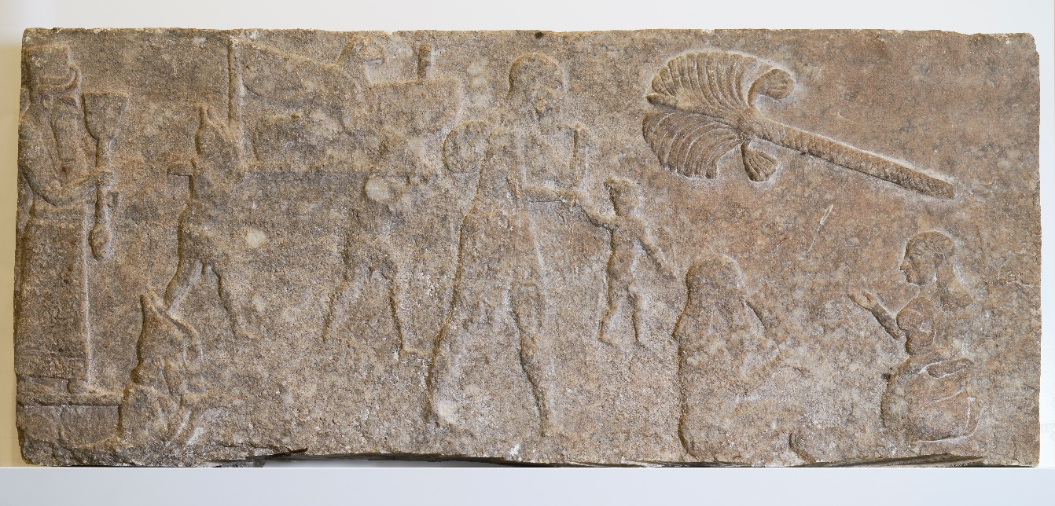
Discovered by Austen Henry Layard between 1846 and 1847 in the Centre
Palace of Nimrud-Kalhu in Iraq, this Assyrian relief is exceptional. Entitled ‘Idols and captives from a conquered nation’, it stems from the monumental double frieze recounting the reign of Tiglath-Pileser III (745–722 BC). From left to right, Assyrian soldiers deport the gods of Babylon and its population. Together with the neighbouring relief in the British Museum, it forms the oldest known deportation scene.
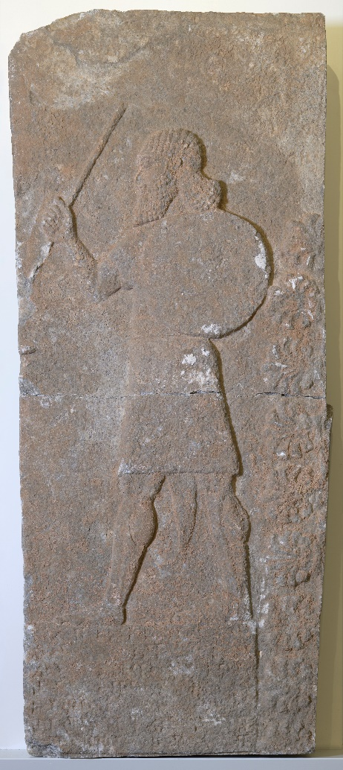 | 8th century BC corner relief, uncovered in 1976 in the Centre Palace of Nimrud-Kalhu, Iraq, by the Polish Archaeological Mission. Originally 2.56 m high, it featured a double register of armed dignitaries separated by a cuneiform inscription and bordered on the right by a tree of life, the symbol of royalty. Presumably deliberately mutilated to sell it, only one of the dignitaries, armed with a shield and brandishing a spear, remains on the inscription, which has yet to be read.
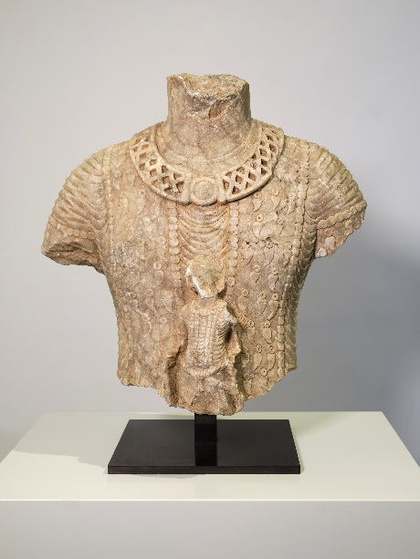 | Torso fragment wearing a pleated tunic and a pearl nets edged royal mantle adorned with pendants, stemming from the monumental statue of a king of Hatra, represented as an orant carrying the figure of Mārān-Shemesh, the Sun God, standing on his legs and wearing a pearl mantle. Discovered in the eastern corridor of the Temple of the Sun (inventory  8/Hatra/247) during the Iraqi excavations carried out in 1959 in the ancient city of Hatra, it is dated from the 2nd–3rd centuries AD.

Illegal transfer of cultural goods – a global problem
The global trade in cultural goods has multiplied in recent decades. It is not only the legal art trade, which promotes mutual understanding and respect as a fair cultural exchange, that has grown, but also the illegal transfer of cultural goods that causes serious and often irreversible damage to cultural heritage. Organised criminal groups are becoming more involved in the illegal trade of cultural property, just as much in legal markets and on the internet as in the illegal underworld markets. The theft, looting and illegal trading of cultural goods deprive affected communities of their cultural heritage, which is part of their history. The looting of archaeological cultural goods irremediably destroys the context of their discovery. Areas rich in cultural property in the Mediterranean region, Asia, Africa and Latin America as well as the Middle East suffer in particular from the looting of archaeological sites.
Cultural goods are special. They are tangible remnants of culture and history as well as expressions of identity for individuals and the community. They shape a society’s self-image and social cohesion. That is why the protection, promotion of the preservation and placement of movable cultural heritage counts today as one of a state’s important duties.

Rules for the Swiss cultural centre
Having one of the highest concentrations of museums in the world, many private collections, global importance as a marketplace for art and exhibition location plus a positive trade balance, make Switzerland a major cultural centre. This basis, international developments and prominent cases in the late 1990s and 2002 of thousands of seized looted archaeological cultural goods in Switzerland, necessitated regulations to facilitate further the legal exchange of cultural goods and combat the illegal transfer of cultural goods.
The CPTA has been in force in Switzerland since 2005. It implements the UNESCO Convention of 1970 on the Means of Prohibiting and Preventing the Illicit Import, Export and Transfer of Ownership of Cultural Property and the UNESCO Convention of 2001 on the Protection of the Underwater Cultural Heritage into Swiss law.
The CPTA provides the requisite legal basis for the import, transit, export, return and transfer of cultural property. The duty of diligence specific to trading in art, declaration requirements for cross-border transport of goods and the general prohibition of any transfer (acquisition, sale, import, placement etc.) of stolen or looted cultural goods play a central role in combating the illegal transfer of cultural property.
The Specialized Body for the International Transfer of Cultural Property at the FOC is responsible for enforcing the CPTA. Since the CPTA came into force, there have been about 270 criminal procedures in Switzerland for contraventions of the Cultural Property Transfer Act and about 6,800 cultural goods have been returned by Switzerland to their countries of origin.
Switzerland has returned 39 cultural goods to Iraq since 2015.

Exploring the archaeological cultural heritage in Iraq
Launched in 1845 thanks to the Western public’s interest in the places mentioned in the Bible, the archaeological exploration of Mesopotamia soon became the scene of fierce competition between the nation states of France and England, both wanting to endow their respective museums, the Louvre and the British Museum, with the most impressive works. It was against this backdrop that Austen Henry Layard carried out excavations at Nimrud-Kalhu between 1846 and 1849, uncovering the slabs of a monumental double parietal frieze from the reign of Tiglath-Pileser III. Both exhibited reliefs stem from this frieze, which adorned a wall of the Centre Palace. Already destroyed in antiquity, this 8th-century BC palace yielded more than a hundred reliefs. Due to a lack of resources, most of them were reburied on site after being partially drawn by Layard, only a selection being transported to the British Museum. Widely published, Layard’s excavations created a popular enthusiasm, which formed the basis for subsequent excavations. The wave of curiosity generated by those spectacular discoveries were the prelude to the subsequent colonisation of the Middle East after the fall of the Ottoman Empire in 1918.

The ancient city of Hatra
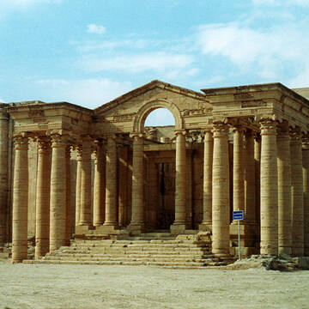 | Discovered in 1906, the Parthian city of Hatra has benefited from systematic excavations carried out by the State Board of Antiquities and Heritage (SBAH) since 1951. Focusing on the religious monuments of the city’s central temenos, they led to the discovery in 1959 of the royal statue from which the bust on display stems. Hatra was the ancient capital of the Parthian king of Arabia, the Rex Arabicus according to ancient sources, until its capture by the Sassanids in 240 AD. Hatra has an important place in world cultural history. That is why the archaeological site has been registered as endangered UNESCO World Cultural Heritage since 1985 (https://whc.unesco.org/en/list/277; last visited on 15 May 2024).
Hatra, © UNESCO Author: Véronique Dauge

Art. 251 No. 1 SCC, SR 311.0
Art. 724 Swiss Civil Code (SCC), SR 210
The ICOM Red List of Cultural Objects at Risk: https://icom.museum/wp-content/uploads/2018/05/RedListIraq_DE2.pdf; last visited on 15 May 2024
Art. 16 CPTA (duty of diligence in the art trade); Art. 24 CPTA (criminal provisions).

