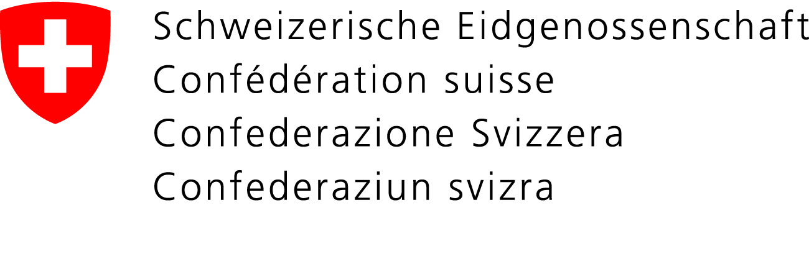 | Eidgenössisches Departement des Innern EDI  Bundesamt für Kultur BAK
Jury Swiss Design Awards 2023

The jury consists of the seven members of the Federal Design Commission elected by the Federal Council and four experts.

President of the Federal Design Commission

Nathalie Herschdorfer
Director, Photo Elysée, Lausanne
Members of the Federal Design Commission
Cécile Feilchenfeldt
Textile designer, Paris (FR)

Dr. Davide Fornari
Professor (Research and Development), Renens / Milano (IT)

David Glättli
Product designer and creative director, Zurich / Tokio (JP)

Andreas Gysin
Graphic designer, coder and artist, Lugano / Paris (FR)

Vera Sacchetti
Design critique and curator, Basel

Ivan Sterzinger
Graphic designer and editor, Zurich

Experts

Andrea Anner
Design & Robotics, Zurich

Florencia Colombo
Researcher, writer and curator in design and material culture, St. Gallen

Sandra Kassenaar
Graphic designer, Amsterdam (NL)

Eveline Roth
Fashion designer and professor, Basel / Bern

